Create/Renew Entryeeze Account

- Go to https://www.entryeeze.com/
  - Click on Sign up!

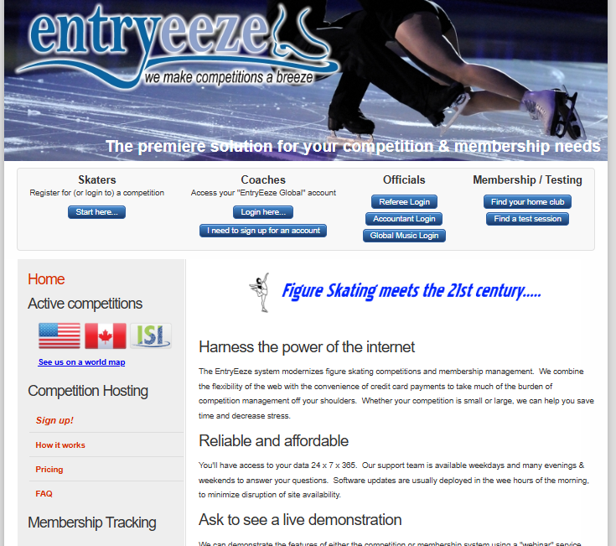

- Click Begin
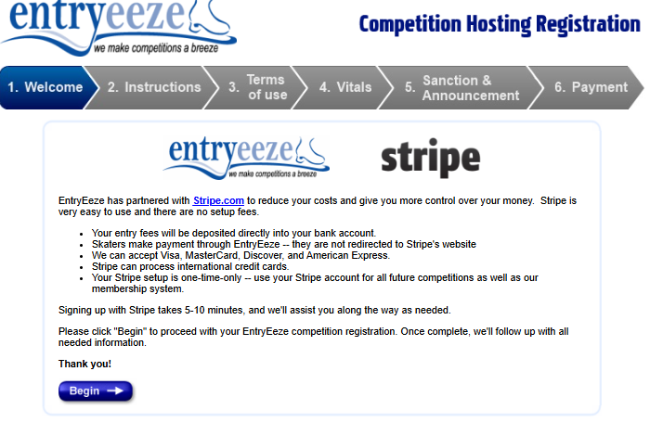

- Enter validation text and hit Next
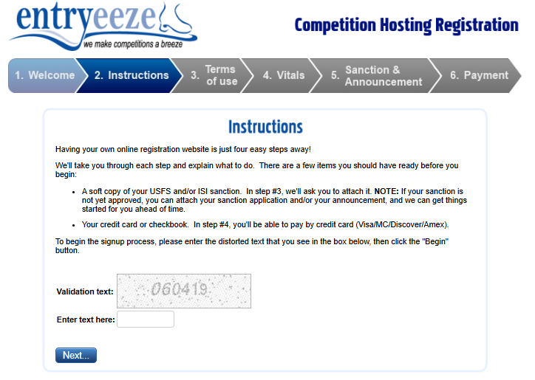

- Check mark Customer agreement and Fee and billing practices, click Next
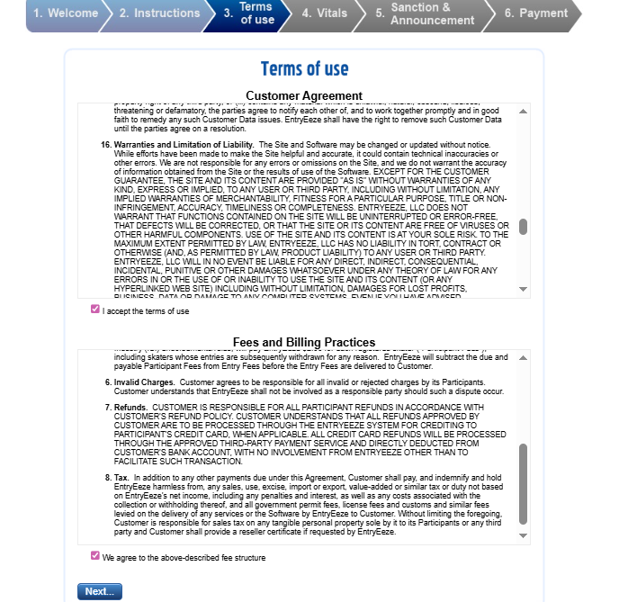
- In the search box, type Ice in the Pines. Our previous year will show up, click on this.
  - Then fill out all the information boxes.
  - Go to the next page, upload the Announcement and Sanction. If you do not have the sanction yet, you can upload this later.
  - Click the option to have Entryeeze enter all the information from your announcement into the site. This is a $55 fee. This is worth it and saves you time!

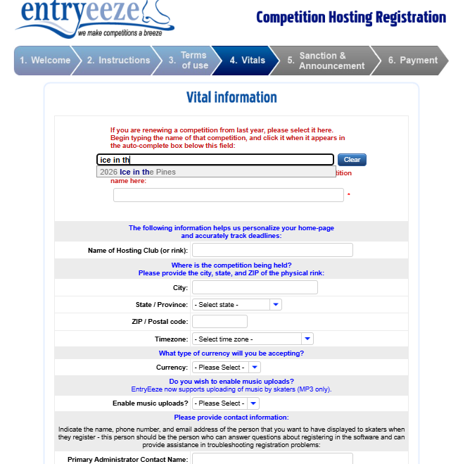

- You will then get a confirmation email.
  - In a day or two, they will email you with your username and login.
- Login, make sure all the deadlines are right.
- Go to Manage>Front Page Content (Ads and Announcements)
  - Edit this information, this will be old info from last year
- Go to Manage>Administrators
  - Create another Admin account and an account for the Referee, Accountant, Music Chair, and Practice Ice chair, and Treasurer

